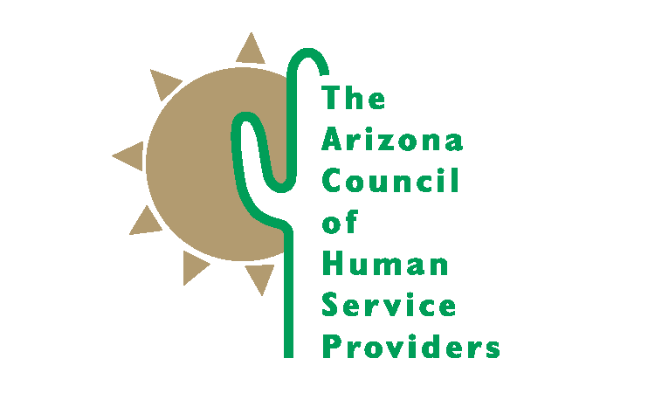
SAVE THE DATE

DAY AT THE CAPITOL
Wednesday, February 13th, 2018
8 AM to 3 PM
Historic Supreme Court Room in the 1938 Capitol Addition

Members of Arizona Council of Human Service Providers
Briefings, committee meetings, meetings with legislators, introductions on the floor, and more!

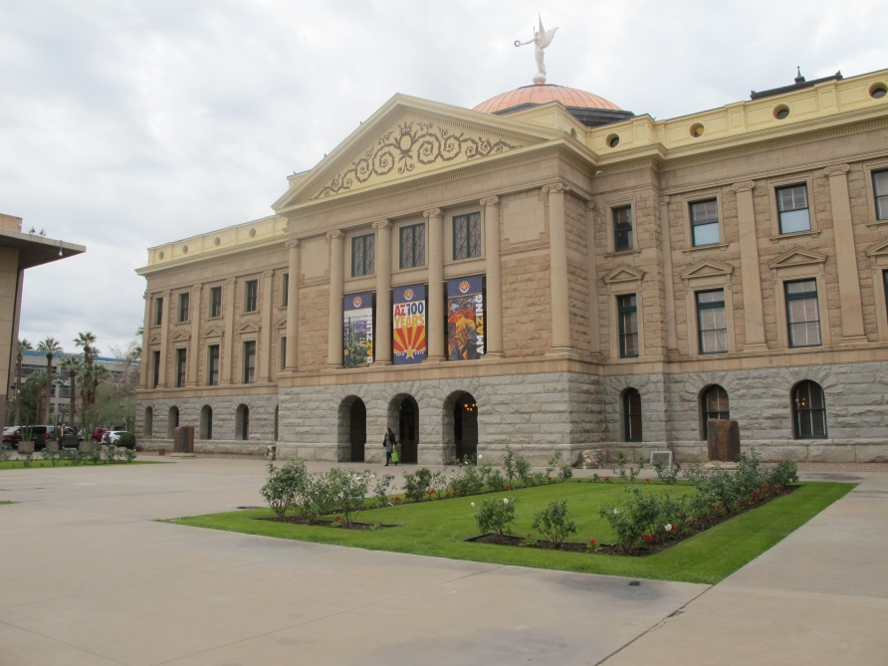

Register Today at:
http://events.constantcontact.com/register/event?llr=fnkjgluab&oeidk=a07efyuyblj9e905c6d

