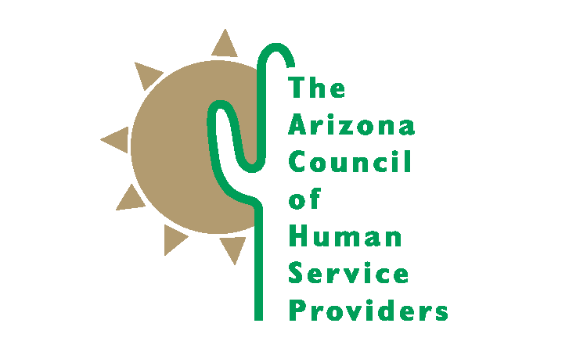
2100 N. Central Avenue, Suite 225 Phoenix, Arizona 85004
602-252-9363 Fax 602-252-8664

ACCOMPLISHMENTS 2017-18

Advocacy Efforts

Arizona Council staff monitored over 600 bills during the 2018 legislative session related to behavoral health, child welfare, juvenile justice, and other related topics. We were able to ensure passage of key pieces of behaivoral health and child welfare legislation, while keeping some misguided policy solutions from moving forward. Arizona Council staff, lobbyists, and members actively engaged in study committees and stakeholder meetings adding the voice of the providers and a reality check for legislators. Our engagement was sought after and appreciated by legislators and staff who asked for our assistance in finding members for stakeholders groups.

We provided weekly legislative updates to our members. We supported our members in building relationships with their state and federal elected officals through our annual Day at the Capitol and Hill Day events. Our legislative, congressional, and administrative advocacy efforts established the Arizona Council as a credible resource to elected offcials, legislative staff, the governors office, and state agencies. We are seen as a problem solving resource for policy makers.

Member Services

The Arizona Council is only as strong as our member organizations. With 98 members this year, who employ over 23,000 staff, operate over 700 facilities, and serve almost a million children, adults, and families, we are a force to be reckoned with. Member organizations receive many benefits of membership including regular communication and technical assistance from Arizona Council staff.

Through monthly general membership and committee meetings with our members, we are able to communicate, learn from, and support each other. Quarterly forums with state agency representatives were held in September, December, March, and June. Community forum topics included presentations on innovations in technology, discussion about changes our messaging on poverty and human service delivery systems, and implementation of the opioid action plan and AHCCCS Complete Care. We also held monthly meetings with staff from AHCCCS and regular participation in the Child Welfare committee with DCS staff.

We began planning for our 2018 Member Conference, Thriving in Times of Change, which will be held November 29-30 at the Black Canyon Conference Center. And started work on our 8th biannual Salary/Benefit Survey, which will survey over 50 positions and added 27 benefits questions as well. The Survey will be available to purchase in the fall 2018.

Specific Iniatives

- 1115 Waiver, Targeted Investment Project
- ACA Repeal and Replace
- AHCCCS Complete Care Implementation
- AHCCCS Policy Committee
- AOC Task Force on Juvenile Detention Alternatives Initiatives
- Arizona State Health Improvement Plan
- Behavioral Health System Reform
- Building Relationships with Health Plans Educational Forums
- Center for Child Well Being Advisory Board
- Day at the Capitol and Hill Day Advocacy Efforts
- DCS Community Advisory Board
- DCS Report Consolidation Work Group
- Families First Child Welfare Finance Reform
- Incompetent, Non-restorable, Dangerous Defendants Committee/Report
- Mental Health America Arizona
- National Council Opioid Project with AHCCCS and Governor’s Office
- Psych Boarding and Title 36 Court Ordered Evaluation and Treatment Issues
- Salary/Benefit Survey (biannual)
- Smoking Cessation Project
- Workforce Development Data Collection Workgroup

Arizona Foundation for Human Service Providers

Behavioral Health Interpreter Academy

The Arizona Foundation for Human Service Providers launched the innovative Behavioral Health Interpreter Academy in August 2015. The Interpreter Academy is a 6 week belended learning training program for bilingual individuals who provide interpretation services in their agencies. Two classes were held in Phoenix and 15 people were trained this year. Participants consistently report they have learned both the interpretation skills and Spanish language vocabulary needed to provide higher quality services to monolingual Spanish speaking clients.

Neurosequential Model in Caregiving

We continued implementmentation of the Neurosequential Model in Caregiving, a foster parent trauma informed care training program. This is a three year collaboration with the ChildTrauma Academy and Dr Bruce Perry. We will build a library of video and other resources and train 60 facilitators to continue the program. Over 2,000 unique individuals people watched the first 17 webinars—either live or through the archived video library. This includes foster, kinship, and adoptive families, child welfare and behavioral health staff, and DCS staff. The Train the Trainer Facilitator Training progam began in the fall 2017 with 42 participants. Two program evaluations were completed, demonstrating that most people who watched the webinars are benefiting from them.

ECSII (Early Childhood Service Intensity Instrument) Facilitator Training

AHCCCS asked the Arizona Foundation for Human Service Providers to coordinate a “train the trainer” training program for providers receiving Targeted Investment funding to begin using the ECSII for screening children ages birth to five. We trained 36 facilitators and an additional 33 staff to use the ECSII. They will then continue to provide training to other service providers in their agency and begin using a uniform screening tool for very young children and their families. We will continue to report the number of providers trained on a monthly basis to the American Academy of Child and Adolescent Psychiatry over the next 12 months.

UoA Supervisors Training Program

We were asked by the University of Arizona to apply with them for a Regional Public Health Training Center Program Grant. The grant was awarded beginning July 2018 to ascertain the training needs of our public health workforce. We will be completing a needs assessment of our members, marketing training programs to our members, and developing a blending learning training program for new supervisors and middle managers.

