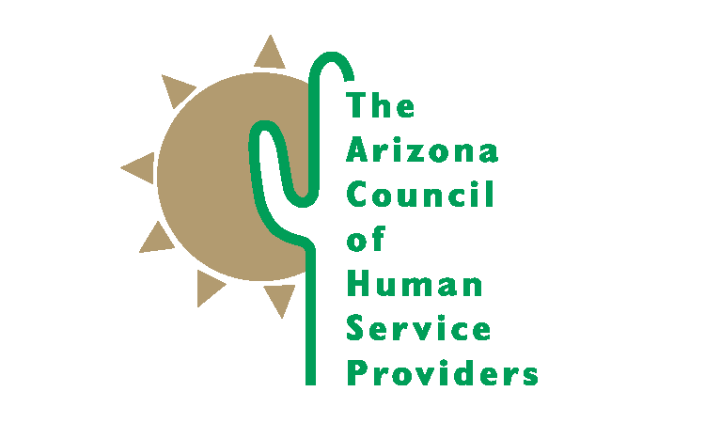
2100 N. Central Avenue, Suite 225 Phoenix, Arizona 85004
602-252-9363 Fax 602-252-8664

ACCOMPLISHMENTS 2016-17

Advocacy Efforts

Arizona Council staff monitored almost 400 bills during the 2017 legislative session related to behavoral health, child welfare, juvenile justice, and other related topics. We were able to ensure passage of key pieces of behaivoral health and child welfare legislation, while keeping some misguided policy solutions from moving forward. Arizona Council staff, lobbyists, and members actively engaged in study committees and stakeholder meetings adding the voice of the providers and a reality check for legislators. Our engagement was sought after and appreciated by legislators and staff who asked for our assistance in finding members for stakeholders groups.

We provided weekly legislative updates to our members. We supported our members in building relationships with their state and federal elected officals through our annual Day at the Capitol and Hill Day events.

Our legislative, congressional, and administrative advocacy efforts established the Arizona Council as a credible resource to elected offcials, legislative staff, the governors office, and state agencies. We are seen as a problem solving resource for policy makers.

Member Services

The Arizona Council is only as strong as our member organizations. With 91 members this year, who employ over 17,000 staff, operate over 700 facilities, and serve over a million children, adults, and families, we are a force to be reckoned with. Member organizations receive many benefits of membership including regular communication and technical assistance from Arizona Council staff.

We held our biannual member conference on November 15 and 16, 2016, The Mosaic of the Future: Bringing Together Partners for Quality Care. The conference focused on innovative, evidence based, and emerging ideas that involve collaborative community efforts to address the transformation of behaivoral health and child welfare services over the next decade. Almost 200 people attended the conference which included keynote addresses by national leaders in trauma informed care and the opioid epidemic as well as 26 other workshops and TED style talks.

We completed the 7th biannual Salary Survey which was distributed to members in December of 2016. We surveyed 54 positions with data broken out by agency budget, region, and number of employees. We had 58 participating agencies employing 14,198 staff and reporting on 11,023 of them. Forty percent were from Maricopa County with good representation of small, medium, and large organizations particpating.

Through monthly general membership and committee meetings with our members, we are able to communicate, learn from, and support each other. Quarterly forums with state agency representatives were held in September, December, March, and June. Community forum topics included presentations on the AHCCCS 1115 Waiver and RFI, Arizona Center for Economic Progress, Circle the City, First Episode Psychoses Clinics, Advocacy, and Occupational Therapy Services in Arizona. We also have monthly meetings with staff from AHCCCS and regular participation in the Child Welfare committee with DCS staff.

Neurosequential Model in Caregiving

We implemented the Neurosequential Model in Caregiving, a foster parent trauma informed care training program. This is a three year collaboration with the ChildTrauma Academy and Dr Bruce Perry. We will build a library of video and other resources and train 60 facilitators to continue the program. Over 1,500 (duplicated) people watched the first three webinars.

Behavioral Health Interpreter Academy

The Arizona Foundation for Human Service Providers launched the innovative Behavioral Health Interpreter Academy in August 2015. The Interpreter Academy is a 6 week belended learning training program for bilingual individuals who provide interpretation services in their agencies. Three classes were held in Phoenix and Tucson and 32 people were trained this year.

Specific Iniatives
- 1115 Waiver and DSRIP
- AHCCCS Policy Committee
- AOC Task Force on Juvenile Detention Alternatives Initiatives
- Arizona State Health Improvement Plan
- Behavioral Health System Reform
- DCS Advisory Board
- Keeping Kids in Families Child Welfare Finance Reform
- Mental Health America Arizona
- National Council Opioid Project with AHCCCS and Governor’s Office
- Salary/Benefit Survey (biannual)
- SB1375 comments and monitoring
- Smoking Cessation Project

