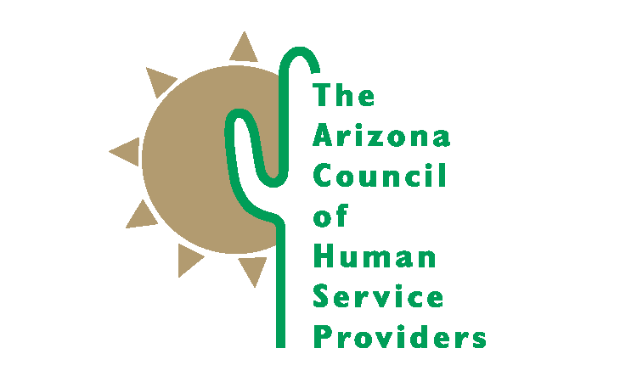
SAVE THE DATE

DAY AT THE CAPITOL
Wednesday, February 17^{th,} 2016
8 AM to 3 PM
Historic Supreme Court Room in the 1938 Capitol Addition

Members of Arizona Council of Human Service Providers
Briefings, committee meetings, meetings with legislators, introductions on the floor, and more!

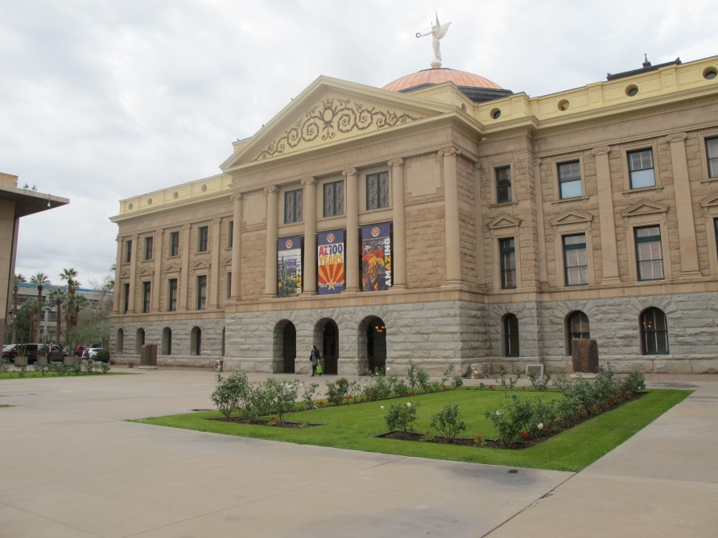

Food Provided by St Mary’s Food Bank Alliance, Community Kitchen Catering
Please RSVP to Bahney Dedolph at bdedolph@azcouncil.com or 602.252.9363

